Copy no:___ May 2023

AEMCK-DMP-03, Rev-0

**Radioactive Waste Inventory Record-Keeping (WIRKs) Using Block Chain Technology at AEMCK**

Prepared by: UZMA ILYAS

PS, AEMCK

Image

Atomic Energy Medical Centre Karachi (AEMCK)

Pakistan Atomic Energy Commission

1. **Back Ground**

Radioactive waste (RAW) management is a critical aspect of nuclear safety and environmental protection. Ensuring the secure, traceable, and immutable record-keeping of RAW from its generation to its final disposal is essential for regulatory compliance, public safety, and organizational accountability. Traditional record-keeping methods, which often rely on centralized databases or manual processes, present challenges such as vulnerability to data tampering, inefficiency in tracking, and difficulties in auditing and compliance.

To address these challenges, block-chain technology offers a promising solution. Block chain’s decentralized, secure, and immutable ledger system can revolutionize RAW inventory management by providing a transparent and tamper-proof method of tracking waste through every stage of its lifecycle. By integrating blockchain technology into the Waste Inventory Record-Keeping System (WIRKs) at institutions such as AEMCK hospital, a novel functionality can be introduced that enhances data integrity, streamlines operations, and ensures compliance with safety and regulatory standards.

This novel approach leverages the decentralized nature of block-chain, where each transaction related to RAW—such as collection, storage, transport, and disposal—is recorded across multiple nodes(departmental records) in a secure and verifiable manner. Each record is encrypted, time-stamped, and linked to previous records, making it virtually impossible to alter historical data without detection. In addition to enhanced security, this system provides full traceability and auditability, allowing stakeholders to monitor the entire waste management process in real-time.

By adopting block-chain technology in RAW management, organizations can significantly improve operational efficiency, reduce costs associated with manual tracking and verification, and ensure a higher level of compliance with international safety standards. The integration of this cutting-edge technology into WIRKs represents a transformative step toward the future of radioactive waste management.

1. **Introduction and Objective**

Radioactive Waste is defined as any Radioactive solid, liquid, or gas which is discarded or residual that remained on the ground or into the air. In numerous studies, waste has been considered a significant problem around the globe which in addition to affecting environmental issues, it has economic issues and human health problems. Due to the population growth and increasing human waste production as well as its destructive effects, waste management faces many challenges and complexities.

Waste management is defined as the ability to deal with Radioactive waste generated and eliminate its destructive effects on the environment, economy, human health, etc

Waste management in hospitals has become a severe threat to the health of the community as well as those working in the hospital due to its inherent toxic and infectious nature. Hospital waste is considered any waste generated during the diagnosis, treatment, immunization of humans. It includes blood-stained bandages, laboratory utensils disposable gloves and surgical instruments, needles, tape, etc..Waste generated in hospitals mainly consists of two types of hazardous and non-hazardous waste. Hazardous wastes include infectious wastes, chemical wastes radioactive wastes, etc. and non-infectious wastes include laboratory utensils, food, and fruits scraps, etc. It is worth mentioning that a wide range of waste disposal methods has been utilized in different countries based on the types of hospital waste and their technology access level. In developed countries, various methods such as mechanical, thermal, radiation, sewage disposal, recycling, incineration, autoclaving, electron beam technology, etc., are used for hospital waste disposal.AEMCK IS phasing incineration to protect the environment.

1. **Current Methodology for RAW Collection and Disposal**

- **Detailed Description of Current Processes**

- **Challenges and Limitations in the Existing System**

- **Data Security and Integrity Concerns**

1. **Introduction to Block-chain Technology**

Block chain is a disruptive technology, currently it has extensively been considered in Radioactive waste management. This technology was widely known as a mechanism for the consensus process in the Bitcoin cryptocurrency but is now referred to as a technology with many applications in various fields like database management, consensus, bitcoin transaction records etc. Blockchain is a distributed ledger technology in which its members record and share transaction records. It has many essential features that provide;

* **Decentralization**, which refers to a database system with open access control in which data is accessible, monitored, stored, and updated in several systems in addition to
* **Security**, data encryption maintains the integrity and availability of the data, by which establishing trust between parties and direct relationships between individuals and formal organizations.
* **Transparency,** preventing data manipulation.
* **Immutability** is one other crucial characteristic of blockchain in which records are stored forever after storage and cannot be modified or altered.
* Reduced Risk of Fraud and Errors

- **Applications of Blockchain in Various Industries**

1. **Novel Functionality for RAW Management Using** 
   1. **Conceptual Framework**

**Block-chain Ledger:** Each transaction (collection or disposal of RAW) is recorded on a decentralized ledger that is immutable and transparent.

**Smart Contracts:** Automated contracts that trigger actions (e.g., sending alerts, initiating disposal processes after 3 to 6 months) when predefined conditions are met.

1. **Design and Implementation**

**Step 1:** **Data Recording**

Each RAW collection instance is recorded on the blockchain with details such as date, time, quantity, and source.

**Step 2: Verification and Validation**

Authorized personnel verify the data, and validation is performed via consensus mechanisms.

**Step 3: Storage and Access**

Data is stored in a secure, decentralized manner, accessible only to authorized users.

**Step 4: Disposal Process**

Smart contracts manage the disposal process, ensuring compliance with safety and regulatory standards.

1. **Methodology for Collection and Disposal of RAW**

**Data Collection and Recording:** ~~Use of IoT Devices: Integrate IoT sensors to automatically~~ data can be collect data on RAW quantities and status.

**Block chain Nodes:** Each department handling RAW can have a blockchain node to record transactions.

**Smart Contracts for Disposal:** Automated Triggers: Smart contracts can trigger notifications for disposal once certain thresholds are met.

**Compliance Checks**: Ensure all disposal actions comply with regulatory requirements.

**Traceability and Auditability**

**Immutable Records:** Every transaction is recorded permanently, providing a complete audit trail.

**Real-Time Monitoring:** Enable real-time tracking of RAW from collection to disposal.

By incorporating block-chain technology into the WIRKs software, the security, transparency, and efficiency of RAW management at AEMCK hospital significantly enhanced. This integration will not only streamline the record-keeping process but also ensure compliance with stringent regulatory standards and improve overall accountability.

#### 6. Benefits of Blockchain Integration

- **Enhanced Data Security and Integrity**

- **Improved Transparency and Accountability**

- **Efficient Record-Keeping and Management**

- **Reduced Risk of Fraud and Errors**

- **Streamlined Compliance with Regulatory Standards**

#### 7. Case Study: Implementation at AEMCK Hospital

- **Pilot Project Overview**

- **Initial Results and Findings**

- **Challenges Faced and Solutions Implemented**

- **Impact on RAW Management Efficiency and Security**

#### 8. Future Prospects and Recommendations

- **Potential for Further Enhancements**

- **Scalability and Adaptability to Other Hospitals/Institutions**

- **Recommendations for Implementation and Best Practices**

#### 9. Conclusion

- **Summary of Findings**

- **Significance of Blockchain Integration in RAW Management**

- **Final Thoughts and Future Directions**

### Detailed Description of Blockchain Integration

#### Conceptual Framework

- **Blockchain Ledger:** Each transaction (collection or disposal of RAW) is recorded on a decentralized ledger that is immutable and transparent.

- **Smart Contracts:** Automated contracts that trigger actions (e.g., sending alerts, initiating disposal processes) when predefined conditions are met.

#### Design and Implementation

- **Step 1: Data Recording**

- Each RAW collection instance is recorded on the blockchain with details such as date, time, quantity, and source.

- **Step 2: Verification and Validation**

- Authorized personnel verify the data, and validation is performed via consensus mechanisms.

- **Step 3: Storage and Access**

- Data is stored in a secure, decentralized manner, accessible only to authorized users.

- **Step 4: Disposal Process**

- Smart contracts manage the disposal process, ensuring compliance with safety and regulatory standards.

### Methodology for Collection and Disposal of RAW

#### Data Collection and Recording

- **Use of IoT Devices:** Integrate IoT sensors to automatically collect data on RAW quantities and status.

- **Blockchain Nodes:** Each department handling RAW can have a blockchain node to record transactions.

#### Smart Contracts for Disposal

- **Automated Triggers:** Smart contracts can trigger notifications for disposal once certain thresholds are met.

- **Compliance Checks:** Ensure all disposal actions comply with regulatory requirements.

#### Traceability and Auditability

- **Immutable Records:** Every transaction is recorded permanently, providing a complete audit trail.

- **Real-Time Monitoring:** Enable real-time tracking of RAW from collection to disposal.

By incorporating blockchain technology into the WIRKs software, you can significantly enhance the security, transparency, and efficiency of RAW management at AEMCK hospital. This integration will not only streamline the record-keeping process but also ensure compliance with stringent regulatory standards and improve overall accountability.

### Additional Tips for Writing the Report

- **Use Visuals:** Include diagrams and flowcharts to illustrate the blockchain integration process.

- **Provide Real-World Examples:** Cite case studies or examples from other industries where blockchain has been successfully implemented.

- **Technical Details:** Include technical specifications and code snippets where necessary to provide a deeper understanding of the integration process.

- **Collaborate with Experts:** Work with blockchain experts to ensure the accuracy and feasibility of your proposed methodology.

By following this outline and incorporating these details, you can create a comprehensive and insightful research report on the novel functionality of RAW management using blockchain technology at AEMCK hospital. To incorporate novel functionality for radioactive waste (RAW) inventory record-keeping (WIRKs) using blockchain technology, you can follow these steps and include them in your research report. Here's an outline and some details to help you structure your report effectively:

**Proposed feature Modal**

The set of features used in this study is extracted by attributes describing the patients from different point of views. These attributes refer to the patient’s personal data, economical condition and physical conditions. Of the initial feature set, from many only select 20 attributes that are related to patient information The Table 1 includes for each row an attribute considered in the dataset, reporting the name in the first column, a brief description in the second column, and the type in the last column. Last row shows the predicted feature:, Isolation Time (isotime), and Release (Rc.

1. **CONCLUSION**

The WIRKs system at AEMCK hospital has been successfully implemented to streamline the management of radioactive waste from collection to disposal. By assigning unique Collection IDs, tracking storage times, and ensuring safe and timely disposal, the system effectively reduces the risk of contamination and improves compliance with regulatory requirements. Furthermore, the system maintains a comprehensive audit trail, ensuring accountability and transparency throughout the entire process.

1. **References:**
2. U.S. NUCLEAR REGULATORY COMMISSION April 1997 Revision 0 REGULATORY GUIDE OFFICE OF NUCLEAR REGULATORY RESEARCH REGULATORY GUIDE 8.39 (Draft was issued as DG-8015) RELEASE OF PATIENTS ADMINISTERED RADIOACTIVE MATERIALS
3. Regulatory Commission guidance on release of radioactive patients Dawn Banghart, CHP Sr. Health Physicist Alt. Radiation Safety Office
4. Regulatory Guide on Radiation Protection (PAK-904.02).
5. “Estimation of the Release Time from Isolation for Patients with Differentiated Thyroid Cancer Treated with High-dose I-131”, Jai Hyuen Lee and Seok Gun Park
6. Radiation safety in the treatment of patient with thyroid disease by radio iodine 1-31,
7. Correspondence Continuing Education Courses for Nuclear Pharmacists and Nuclear Medicine Professionals VOLUME IX, NUMBER 1 “Current Practice for the Release of Patients Administered Radioactive Materials”, By: Steven G. Marsh, MS The Ohio State University Medical Center, Columbus, OH and Robert E. Reiman, MD Duke University Medical Center, Durham,
8. Isolation period of 131i administered patients at nimra jamshoro Pakistan, Sajjad Ahmed Memon, Naeem Ahmed Laghari, Fayaz Hussain Mangi, Muhammad Mubashar Hussain, Sadiq Hussain Nohario Nuclear Institute of Medicine and Radiotherapy (NIMRA), Pakistan
9. Radiation Exposure From Outpatient Radioactive Iodine (131I) Therapy for Thyroid Carcinoma, Perry W. Grigsby, MD Barry A. Siegel, MD Susan Baker, MBA John O. Eichling, PhD
10. Releasing Nuclear Medicine Patients to the Public: Dose Calculations and Discharge Instructions Robert E. Reiman, MD Radiation Safety Division Duke University Medical Center Durham, NC
11. Release of Patients or Human Research Subjects Administered Radioactive Materials
12. INTERNATIONAL PATIENT RELEASE PRACTICES FOLLOWING IODINE-131 THERAPY, Brian E. Holian, Acting Director /RA/ RLorson for BHolian Office of Federal and State Materials and Environmental Management Programs
13. Release of Patients Containing Therapeutic Dosages of lodine-131 from Hospitals James E. Carey, Thomas M. Kumpuris and Mark C. Wrobel Division of Nuclear Medicine, University of Michigan Medical Center and Medical Physics Consultants, Inc., Ann Arbor, Michigan
14. Radiation safety in the treatment of patient with thyroid disease by radio iodine 1-31,

**ANNEXURE-I**

As we know the incidence of thyroidal issues are 3 in 100,000 per year, and ratio of female is double then male (2:1).Types: Pappilary (80%), Follicular Thyroid carcinoma (20%) and modularly thyroid carcinoma not takeup Radio Iodine .

For diagnostic purposes usually much less than 1 mCi (37 MBq)

|  |  |
| --- | --- |
| **Iodine Administration**  **(mci)** | **Thyroid examination** |
| **08-15** | Diffuse toxic goitres.  Primary hypothyroidism (elevated TSH)  Inherited defects in thyroid hormone synthesis  Nutritional Iodide Deficiency  Goitrogens (e.g., PTU) |
| **15-30** | Multi-nodular goitres. |
| **50** | For hyperthyroidism or non-cancerous goitre. It can help reduced the size of benign nodules that cause hyperthyroidism and can make thyroid gland less active and reduce the symptoms such as heart rate increase, tremors and weight loss. |
| **100** | In thyroid cancer, 131I can be used to eliminate tumor tissue that cannot be removed surgically but still captures iodine; this mid-range dose also used to treat hyperthyroidism; however it is also used to treat thyroid cancer such as differentiated thyroid cancer. It can help to destroy remaining thyroid cells in thyroid gland and in body, after surgical removal of thyroid gland |
| **150** | this higher dose can cure differentiated thyroid cancer. It can help to  destroy any remaining cell in thyroid gland or elsewhere in body after  surgical removal of gland. |
| **80 to 150 mci** | the uptake of a tracer dose of iodine, and the type of thyroid disorder (diffuse or nodular); |
| **200** | this high dose of iodine is used in rare case and generally reserved for  more aggressive forms of thyroid cancer or for patients who have  experienced a recurrence of cancer. Basically this dose is generally used  to ablate the remaining thyroid and metastases. |

**Table-A1: Iodine doses for therapeutic purpose**

|  |  |
| --- | --- |
| **Bench Mark Dose Level** | |
| 0.5 rem (5mSv) | “Most exposed” person from patients administered radionuclide therapy |
| 0.3 rem (300 mSv) | Typical natural background 1 |
| 0.1 rem(100 mSv) | Typical natural background 1 |

**Table-A2: safe limits**

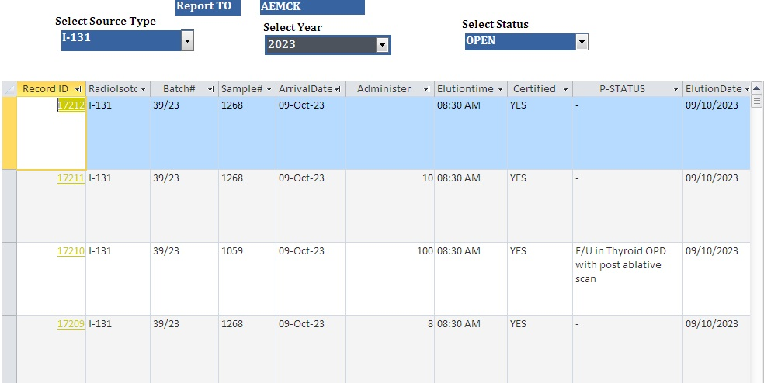

**Figure:A1 All Iodien -131 treated patient Data**

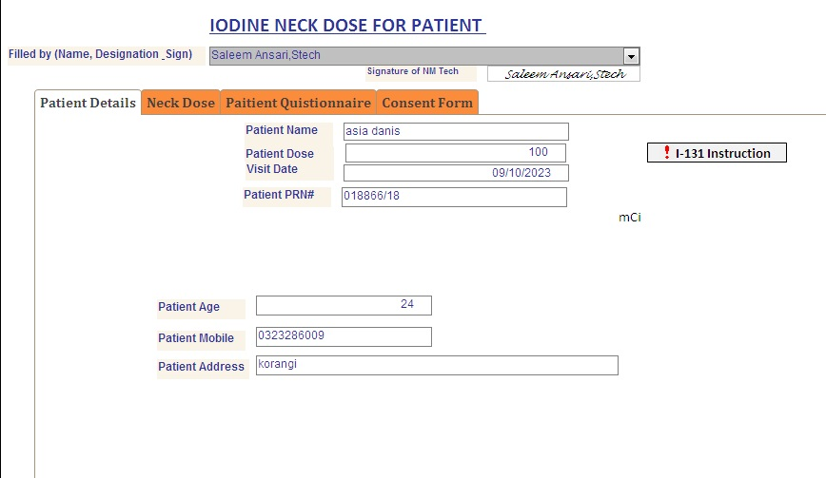

**Figure:3 Singe Patient Medical Details**

**Figure:4 Release Deceision Making Platform**

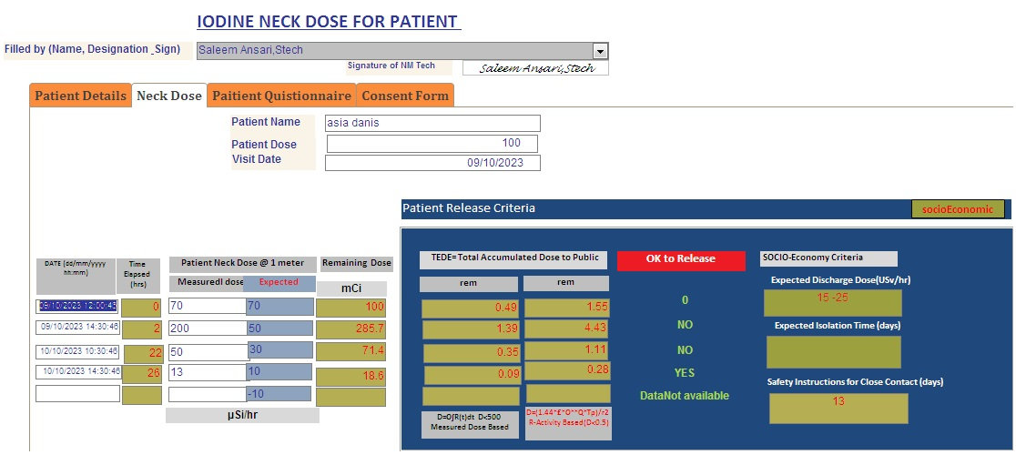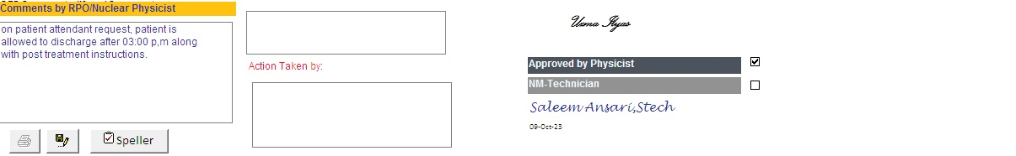

1.5-2

**Tab le:1 I-131 In- Patient administered with 50 mCi**

|  |  |  |  |  |  |  |  |  |
| --- | --- | --- | --- | --- | --- | --- | --- | --- |
| **No.ofPatient** | **Type** | **Patient Name** | **Admin-dose** | **DischargeDate** | **Discharge Dose** | **Days of Admission** | **Days of Admission** | **visist Date** |
|  |  |  | **(mci)** |  | **(Usv/hr)** | **(hr)** | **(days)** |  |
|  |  |  | **(mci)** |  | **(Usv/hr)** | **(Hrs)** | **days** |  |
| 1 | I-131 | Tahira Nisar | 50 | 11/09/2020 | 22 | 72 | 3.0 | 08/09/2020 |
| 2 | I-131 | Irshad Bibi | 50 | 07/10/2020 | 11 | 24 | 1.0 | 06/10/2020 |
| 3 | I-131 | TAHIRA | 50 | 03/11/2020 | 28.6 | 24 | 1.0 | 02/11/2020 |
| 4 | I-131 | NAZIA | 50 | 11/11/2020 | 10 | 48 | 2.0 | 09/11/2020 |
| 5 | I-131 | Sabir Ali | 50 | 11/12/2020 | 8.5 | 24 | 1.0 | 10/12/2020 |
| 6 | I-131 | Mah Rukh | 50 | 29/12/2020 | 13.75 | 0 | 0.0 | 29/12/2020 |
| 7 | I-131 | Ubaidurrahman | 50 | 15/01/2021 | 20.0 | 48 | 2.0 | 13/01/2021 |
| 8 | I-131 | Murshid Hussain | 50 | 10/02/2021 | 7 | 48 | 2.0 | 08/02/2021 |
| 9 | I-131 | Huma Abdul HafeeZ | 50 | 24/02/2021 | 10 | 48 | 2.0 | 22/02/2021 |
| 10 | I-131 | Nosheen | 50 | 30/03/2021 | 15.14 | 24 | 1.0 | 29/03/2021 |
| 11 | I-131 | Jamila A khaliq | 50 | 09/04/2021 | 12.3 | 48 | 2.0 | 07/04/2021 |
| 12 | I-131 | Saima | 50 | 14/04/2021 | 16 | 48 | 2.0 | 12/04/2021 |
| 13 | I-131 | Shagufta | 50 | 22/04/2021 | 14 | 48 | 2.0 | 20/04/2021 |
| 14 | I-131 | Saima | 50 | 27/04/2021 | 21 | 24 | 1.0 | 26/04/2021 |
| 15 | I-131 | Hina Naz | 50 | 28/04/2021 | 18 | 24 | 1.0 | 27/04/2021 |
| 16 | I-131 | Qaisar | 50 | 08/05/2021 | 19 | 24 | 1.0 | 07/05/2021 |
| 17 | I-131 | salma azeem | 50 | 01/06/2021 | 19 | 24 | 1.0 | 31/05/2021 |
| 18 | I-131 | saniya Asif | 50 | 10/08/2021 | 13 | 24 | 1.0 | 09/08/2021 |
| 19 | I-131 | MRS. HALEEMA | 50 |  |  |  | 1.0 | 27/08/2021 |
| 20 | I-131 | FEHMIDA MUMTAZ | 50 | 30/08/2021 | 9 | 48 | 2.0 | 28/08/2021 |
| 21 | I-131 | Haleema | 50 | 28/08/2021 | 21 | 0 | 0.0 | 28/08/2021 |
| 22 | I-131 | NAJMA MAROOF | 50 | 02/09/2021 | 75 | 24 | 1.0 | 01/09/2021 |
| 23 | I-131 | AMBAR SHABBIR | 50 | 27/09/2021 | 4.9 | 48 | 2.0 | 25/09/2021 |
| 24 | I-131 | SAMINA W/O SABRULLAH | 50 | 16/10/2021 | 46 | 48 | 2.0 | 14/10/2021 |
| 25 | I-131 | DILSHADA | 50 | 27/10/2021 | 7.3 | 48 | 2.0 | 25/10/2021 |
| 26 | I-131 | MABLE MOON | 50 | 27/10/2021 | 5 | 48 | 2.0 | 25/10/2021 |
| 27 | I-131 | RABDINO | 50 | 20/11/2021 | 13 | 48 | 2.0 | 18/11/2021 |
| 28 | I-131 | GUL PARI | 50 | 21/12/2021 | 15.5 | 24 | 1.0 | 20/12/2021 |
| 29 | I-131 | MANAHIL GUL | 50 | 30/12/2021 | 16.5 | 24 | 1.0 | 29/12/2021 |
| 30 | I-131 | RUBINA SHAHBAZ | 50 | 19/01/2022 | 7.2 | 48 | 2.0 | 17/01/2022 |
| 31 | I-131 | HINA YASIR | 50 | 08/02/2022 | 25 | 24 | 1.0 | 07/02/2022 |
| 32 | I-131 | MRS NOUSHEEN | 50 | 19/02/2022 09:00:00 | 15.41 | 57 | 2.4 | 17/02/2022 |
| 33 | I-131 | SADAF TAIMOOR | 50 | 19/02/2022 09:00:00 | 17.19 | 33 | 1.4 | 18/02/2022 |
| 34 | I-131 | SEHRISH | 50 | 01/03/2022 10:10:19 | 13.5 | 34 | 1.4 | 28/02/2022 |
| 35 | I-131 | ZEHRA | 50 | 03/03/2022 10:30:55 | 13.4 | 58 | 2.4 | 01/03/2022 |
| 36 | I-131 | MUREED ABAS | 50 | 07/07/2022 12:10:09 | 10 | 36 | 1.5 | 06/07/2022 |
| 37 | I-131 | Farhat Sultan | 50 | 14/07/2022 11:00:02 |  | 35 | 1.5 | 13/07/2022 |
| 38 | I-131 | Mai khan | 50 | 22/07/2022 12:30:53 | 20 | 36 | 1.5 | 21/07/2022 |
| 39 | I-131 | Gulshan Bibi | 50 | 04/08/2022 12:02:29 | 17 | 60 | 2.5 | 02/08/2022 |
| 40 | I-131 | Zubaida Yaseen | 50 | 12/08/2022 10:30:32 | 5.4 | 58 | 2.4 | 10/08/2022 |
| 41 | I-131 | Arshee | 50 | 23/08/2022 11:41:33 | 13.45 | 11 | 0.5 | 23/08/2022 |
| 42 | I-131 | Hameeda | 50 | 31/08/2022 10:25:32 | 16.5 | 34 | 1.4 | 30/08/2022 |
| 43 | I-131 | Javiraj | 50 | 20/09/2022 10:25:14 | 17.0 | 34 | 1.4 | 19/09/2022 |
| 44 | I-131 | Shahida Perveen | 50 | 15/09/2022 12:25:14 | 6.5 | 36 | 1.5 | 14/09/2022 |
| 45 | I-131 | shazia | 50 | 14/09/2022 10:25:14 | 10 | 34 | 1.4 | 13/09/2022 |
| 46 | I-131 | ruby faisal | 50 | 14/09/2022 10:25:15 | 14 | 34 | 1.4 | 13/09/2022 |
| 47 | I-131 | Tasneem Siraj | 50 | 08/09/2022 10:25:15 | 10.6 | 34 | 1.4 | 07/09/2022 |
| 48 | I-131 | Nimra Saqib | 50 | 05/10/2022 11:07:11 | 13 | 35 | 1.5 | 04/10/2022 |
| 49 | I-131 | Sumaira | 50 | 05/10/2022 11:07:11 | 9 | 35 | 1.5 | 04/10/2022 |
| 50 | I-131 | Mumtaz Ali | 50 | 11/10/2022 12:48:13 | 16 | 36 | 1.5 | 10/10/2022 |
| 51 | I-131 | zahida akhter | 50 | 25/10/2022 10:41:00 | 20 | 34 | 1.4 | 24/10/2022 |
| 52 | I-131 | shaista | 50 | 18/10/2022 12:41:01 | 14 | 36 | 1.5 | 17/10/2022 |
| 53 | I-131 | Umaira Saleem | 50 | 01/11/2022 13:47:23 | 19 | 37 | 1.5 | 31/10/2022 |
| 54 | I-131 | Asma yousuf | 50 | 22/12/2022 9:31 | 15 | 48 | 2.0 | 21/12/2022 |
| 55 | I-131 | Zahra | 50 | 22/11/2022 10:31:46 | 18 | 34 | 1.4 | 21/11/2022 |
| 56 | I-131 | Bibi Hoor Jamal | 50 | 07/12/2022 12:06:30 | 23.5 | 36 | 1.5 | 06/12/2022 |
| 57 | I-131 | Farheen | 50 | 20/12/2022 12:15:12 | 28.2 | 36 | 1.5 | 19/12/2022 |
| 58 | I-131 | Asma yousuf | 50 | 14/12/2022 11:30:32 | 15.6 | 59 | 2.5 | 12/12/2022 |
| 59 | I-131 | haseena | 50 | 03/01/2023 10:45:39 | 33 | 34 | 1.4 | 02/01/2023 |
| 60 | I-131 | rub dino | 50 | 03/01/2023 10:45:07 | 24 | 34 | 1.4 | 02/01/2023 |
| 61 | I-131 | Azra rafeeque | 50 | 28/12/2022 12:00:08 | 16 | 48 | 2.0 | 30/012/2022 |
| 62 | I-131 | Anmol | 50 | 08/01/2023 17:35:35 | 0 | 65 | 2.7 | 06/01/2023 |
| 63 | I-131 | Tehreem Saba | 50 | 19/01/2023 11:30:49 | 27.5 | 11 | 0.5 | 19/01/2023 |
| 64 | I-131 | nisha naveed | 50 | 18/01/2023 11:15:50 | 29.4 | 35 | 1.5 | 17/01/2023 |
| 65 | I-131 | salma khatoonn | 50 | 01/02/2023 10:28:30 | 13 | 58 | 2.4 | 30/01/2023 |
| 66 | I-131 | Mariam Nosheen | 50 | 28/02/2023 10:03:27 | 25 | 34 | 1.4 | 27/02/2023 |
| 67 | I-131 | iqra | 50 | 21/02/2023 10:15:29 | 35 | 72 | 3.0 | 24/02/2023 |
| 68 | I-131 | saima shahbaz | 50 | 09/03/2023 10:56:56 | 14 | 34 | 1.4 | 08/03/2023 |
| 69 | I-131 | shumaila bibi | 50 | 14/03/2023 11:10:03 | 35 | 35 | 1.5 | 13/03/2023 |
| 70 | I-131 | Mah Ganj | 50 | 24/03/2023 09:38:53 | 25 | 57 | 2.4 | 22/03/2023 |
| 71 | I-131 | fahmida | 50 | 06/04/2023 10:08:43 | 27 | 82 | 3.4 | 03/04/2023 |
| 72 | I-131 | Makhmal Bibi | 50 | 18/04/2023 10:27:45 | 19.5 | 34 | 1.4 | 17/04/2023 |
| 73 | I-131 | ghulam aneesa | 50 | 04/05/2023 09:58:34 | 20 | 33 | 1.4 | 03/05/2023 |
| 74 | I-131 | Saira | 50 | 05/05/2023 10:05:35 | 16 | 58 | 2.4 | 03/05/2023 |
| 75 | I-131 | Badshah Izzat | 50 | 11/05/2023 11:30:57 | 20 | 59 | 2.5 | 09/05/2023 |
| 76 | I-131 | Najma | 50 | 23/05/2023 11:57:59 | 30 | 35 | 1.5 | 22/05/2023 |
| 77 | I-131 | NAJMA NASEER UDDIN | 50 | 31/05/2023 10:30:50 | 15 | 58 | 2.4 | 29/05/2023 |
| 78 | I-131 | SUMAIRA | 50 | 14/06/2023 10:45:59 | 15 | 58 | 2.4 | 12/06/2023 |
| 79 | I-131 | Bina shabbir | 50 | 22/06/2023 10:07:51 | 16.5 | 34 | 1.4 | 21/06/2023 |
| 80 | I-131 | sanum bilawel | 50 | 22/06/2023 10:45:18 | 11.5 | 34 | 1.4 | 21/06/2023 |
| 81 | I-131 | TAHIRA NASIR | 50 | 04/07/2023 09:58:01 | 22 | 39 | 1.6 | 06/07/2023 |
| 82 | I-131 | ZEHRA | 50 | 06/07/2023 09:58:43 | 18 | 9 | 0.4 | 06/07/2023 |
| 83 | I-131 | nasreen | 50 | 18/07/2023 12:00:08 | 26 | 36 | 1.5 | 17/07/2023 |
| 84 | I-131 | AL;I MOHAMMSAD | 50 | 05/08/2023 12:15:27 | 27 | 36 | 1.5 | 04/08/2023 |
| 85 | I-131 | Mrs Kiran Asim | 50 | 05/09/2023 11:57:57 | 25 | 35 | 1.5 | 04/09/2023 |
| 86 | I-131 | naheed naeem | 50 | 29/08/2023 12:22:59 | 20 | 12 | 0.5 | 30/08/2023 |
| 87 | I-131 | Mureed Abbas | 50 | 03/10/2023 10:30:55 | 25 | 34 | 1.4 | 02/10/2023 |
| 88 | I-131 | Sahibzadi | 50 | 09/10/2023 09:46:45 | 90 | 9 | 0.4 | 09/10/2023 |

**Tabel:2 I-131 In- Patient administered with 100 mCi**

|  |  |  |  |  |  |  |  |  |
| --- | --- | --- | --- | --- | --- | --- | --- | --- |
| **No.ofPatient** | **Type** | **Patient Name** | **Admin-dose** | **DischargeDate** | **Discharge Dose** | **Days of Admission** | **Days of Admission** | **visist Date** |
|  |  |  | **(mci)** |  | **(Usv/hr)** | **(hr)** | **(days)** |  |
| 1 | I-131 | BANO | 100 | 16/09/2020 | 15 | 48 | 2.0 | 14/09/2020 |
| 2 | I-131 | Rukhsana Perveen | 100 | 14/10/2020 | 3 | 48 | 2.0 | 12/10/2020 |
| 3 | I-131 | Maryam | 100 | 15/10/2020 | 11.86 | 24 | 1.0 | 14/10/2020 |
| 4 | I-131 | Sumaira Zareen | 100 | 26/01/2021 | 21 | 24 | 1.0 | 25/01/2021 |
| 5 | I-131 | Samreen | 100 | 24/02/2021 | 11.0 | 48 | 2.0 | 22/02/2021 |
| 6 | I-131 | Syed Zareen Ahmad Shah | 100 | 29/04/2021 | 16 | 72 | 3.0 | 26/04/2021 |
| 7 | I-131 | Bushra | 100 | 02/06/2021 | 12 | 48 | 2.0 | 31/05/2021 |
| 8 | I-131 | SUMAIRA W/O SOHAIL | 100 | 19/06/2021 | 20.6 | 48 | 2.0 | 17/06/2021 |
| 9 | I-131 | ALLAH BACHAI | 100 | 08/10/2021 | 33 | 48 | 2.0 | 06/10/2021 |
| 10 | I-131 | ABIDA BANO | 100 | 16/11/2021 | 53 | 24 | 1.0 | 15/11/2021 |
| 11 | I-131 | TABASUM SOHRAB | 100 | 01/12/2021 | 15 | 48 | 2.0 | 29/11/2021 |
| 12 | I-131 | SHAKAL | 100 | 10/12/2021 | 8.7 | 48 | 2.0 | 08/12/2021 |
| 13 | I-131 | AYESHA MUSHTAQ | 100 | 11/12/2021 | 17.5 | 48 | 2.0 | 09/12/2021 |
| 14 | I-131 | IQRA | 100 | 11/01/2022 | 74 | 24 | 1.0 | 10/01/2022 |
| 15 | I-131 | TASMEEN | 100 | 12/01/2022 | 20.1 | 48 | 2.0 | 10/01/2022 |
| 16 | I-131 | AMNA HANIF | 100 | 18/02/2022 09:25:00 | 9.7 | 57 | 2.4 | 16/02/2022 |
| 17 | I-131 | MAH RUKH | 100 | 22/02/2022 10:30:31 | 20.1 | 34 | 1.4 | 21/02/2022 |
| 18 | I-131 | NIDA FARMAN | 100 | 07/07/2022 01:45:10 | 38 | 25 | 1.0 | 06/07/2022 |
| 19 | I-131 | maimoona munzoor | 100 | 17/01/2023 11:25:50 | 70 | 35 | 1.5 | 16/01/2023 |
| 20 | I-131 | Abdul Hameed | 100 | 08/03/2023 12:18:22 | 18 | 60 | 2.5 | 06/03/2023 |
| 21 | I-131 | KHUSH NIAZ | 100 | 31/05/2023 11:39:03 | 26 | 59 | 2.5 | 29/05/2023 |
| 22 | I-131 | HAMEEDDA A.RASHEED | 100 | 21/06/2023 09:50:21 | 26.5 | 57 | 2.4 | 19/06/2023 |
| 23 | I-131 | KAVITA | 100 | 04/07/2023 09:58:44 | 25 | 39 | 1.6 | 06/07/2023 |
| 24 | I-131 | HUMAIRA SALEEM | 100 | 21/07/2023 12:25:45 | 14 | 12 | 0.5 | 22/07/2023 |
| 25 | I-131 | Poor bai | 100 | 26/07/2023 12:09:08 | 24 | 60 | 2.5 | 24/07/2023 |
| 26 | I-131 | sairA | 100 | 25/07/2023 12:00:50 | 55 | 36 | 1.5 | 24/07/2023 |
| 27 | I-131 | asia danis | 100 | 09/10/2023 09:46:46 | 200 | 9 | 0.4 | 09/10/2023 |

**Tabel:3 I-131 In- Patient administered with 150 mCi**

|  |  |  |  |  |  |  |  |  |
| --- | --- | --- | --- | --- | --- | --- | --- | --- |
| **No.ofPatient** | **Type** | **Patient Name** | **Admin-dose** | **DischargeDate** | **Discharge Dose** | **Days of Admission** | **Days of Admission** | **visist Date** |
|  |  |  | **(mci)** |  | **(Usv/hr)** | **(hr)** | **(days)** |  |
| 1 | I-131 | yumna | 150 | 14/09/2022 | 20 | 48 | 2 | 12/09/2022 |
| 2 | I-131 | Ghulam Ali | 150 | 01/10/2020 | 40 | 48 | 2 | 29/09/2020 |
| 3 | I-131 | Neelam | 150 | 12/11/2020 | 10 | 72 | 3 | 09/11/2020 |
| 4 | I-131 | Zahida Hanif | 150 | 20/11/2020 | 15 | 72 | 3 | 17/11/2020 |
| 5 | I-131 | Haseena Bano | 150 | 28/11/2020 | 45 | 48 | 2 | 26/11/2020 |
| 6 | I-131 | Asia | 150 | 04/02/2021 | 38 | 72 | 3 | 01/02/2021 |
| 7 | I-131 | Maira | 150 | 10/02/2021 | 17 | 72 | 3 | 13/02/2021 |
| 8 | I-131 | Saira M Farooq | 150 | 12/03/2021 | 11.5 | 48 | 2 | 10/03/2021 |
| 9 | I-131 | Aziza Bibi | 150 | 24/03/2021 | 7.7 | 48 | 2 | 22/03/2021 |
| 10 | I-131 | Allah Bachai | 150 |  |  |  | 2 | 31/03/2021 |
| 11 | I-131 | Allah Bachai | 150 | 03/04/2021 | 43 | 48 | 2 | 01/04/2021 |
| 12 | I-131 | Bashira Bibi | 150 | 14/04/2021 | 50 | 0 | 0 | 14/04/2021 |
| 13 | I-131 |  | 150 | 15/04/2021 | 52 | 24 | 1 | 14/04/2021 |
| 14 | I-131 | Ahmed Shah | 150 | 05/05/2021 | 30 | 48 | 2 | 03/05/2021 |
| 15 | I-131 | MUZAFFAR ALI | 150 | 28/05/2021 | 27.5 | 72 | 3 | 25/05/2021 |
| 16 | I-131 | Fouzia | 150 | 10/06/2021 | 17 | 72 | 3 | 07/06/2021 |
| 17 | I-131 | KEWAL S/O NEMO | 150 | 30/06/2021 | 19 | 48 | 2 | 28/06/2021 |
| 18 | I-131 | ABDUL RAZZAQ | 150 | 08/07/2021 | 16 | 48 | 2 | 06/07/2021 |
| 19 | I-131 | MARYAM M.ALAM | 150 | 11/09/2021 | 34 | 24 | 1 | 10/09/2021 |
| 20 | I-131 | SHAHIDA ISMAIL | 150 | 15/10/2021 | 33 | 72 | 3 | 12/10/2021 |
| 21 | I-131 | MAIRA WAQAS | 150 | 03/11/2021 | 28 | 48 | 2 | 01/11/2021 |
| 22 | I-131 | ASMA W/O USAMA | 150 | 10/11/2021 | 37 | 48 | 2 | 08/11/2021 |
| 23 | I-131 | MEHNAZ | 150 | 23/11/2021 | 20 | 24 | 1 | 22/11/2021 |
| 24 | I-131 | FATIMA BIBI | 150 | 15/12/2021 | 15 | 48 | 2 | 13/12/2021 |
| 25 | I-131 | JAMEELA | 150 | 22/12/2021 | 15.5 | 48 | 2 | 20/12/2021 |
| 26 | I-131 | MEWA RAM | 150 | 29/12/2021 | 24 | 24 | 1 | 28/12/2021 |
| 27 | I-131 | MALA NASEER | 150 | 19/01/2022 | 17.5 | 48 | 2 | 17/01/2022 |
| 28 | I-131 | AQSA YASIR | 150 | 26/01/2022 | 10.8 | 48 | 2 | 24/01/2022 |
| 29 | I-131 | MUZAFFAR ALI | 150 | 03/02/2022 09:40:00 | 9.38 | 33 | 1.375 | 02/02/2022 |
| 30 | I-131 | AMiNA | 150 | 09/02/2022 10:15:00 | 15.38 | 58 | 2.416666667 | 07/02/2022 |
| 31 | I-131 | MRS MAJIDA RIND | 150 | 25/02/2022 09:10:00 | 19.8 | 48 | 2 | 23/02/2022 |
| 32 | I-131 | Bibi Khatoon | 150 | 05/08/2022 12:15:29 | 25 | 84 | 3.5 | 02/08/2022 |
| 33 | I-131 | FOUZIA GHULAM NABI | 150 | 18/08/2022 10:04:14 | 14 | 34 | 1.416666667 | 17/08/2022 |
| 34 | I-131 | Fahmeeda | 150 | 12/08/2022 10:30:14 | 13.2 | 58 | 2.416666667 | 10/08/2022 |
| 35 | I-131 | ALI MUHAMMAD | 150 | 26/08/2022 09:41:33 | 16.5 | 33 | 1.375 | 25/08/2022 |
| 36 | I-131 | haseen bano | 150 | 31/08/2022 10:14:32 | 13.65 | 58 | 2.416666667 | 29/08/2022 |
| 37 | I-131 | Asia Danish | 150 | 07/09/2022 10:25:15 | 7.9 | 58 | 2.416666667 | 05/09/2022 |
| 38 | I-131 | Hafsa | 150 | 22/09/2022 10:30:05 | 15.4 | 58 | 2.416666667 | 20/09/2022 |
| 39 | I-131 | Zahid Ali | 150 | 13/10/2022 12:48:13 | 10 | 84 | 3.5 | 10/10/2022 |
| 40 | I-131 | kokab | 150 | 27/10/2022 10:41:00 | 74 | 82 | 3.416666667 | 24/10/2022 |
| 41 | I-131 | Abdul quddus | 150 | 23/10/2022 11:15:00 | 40 | 83 | 3.458333333 | 20/10/2022 |
| 42 | I-131 | Maria | 150 | 02/11/2022 13:00:22 | 8 | 61 | 2.541666667 | 31/10/2022 |
| 43 | I-131 | zahida | 150 | 24/11/2022 12:10:46 | 20.1 | 84 | 3.5 | 21/11/2022 |
| 44 | I-131 | aalya | 150 | 07/12/2022 12:06:29 | 14.5 | 60 | 2.5 | 05/12/2022 |
| 45 | I-131 | Mehnaz | 150 | 15/12/2022 11:48:31 | 7.5 | 59 | 2.458333333 | 13/12/2022 |
| 46 | I-131 | Shazia | 150 | 20/12/2022 12:15:32 | 125 | 36 | 1.5 | 19/12/2022 |
| 47 | I-131 | aziza | 150 | 28/12/2022 11:13:08 | 27 | 13 | 0.541666667 | 29/12/2022 |
| 48 | I-131 | Hazir mohammad | 150 | 11/01/2023 10:15 | 30 | 48 | 2 | 09/01/2023 |
| 49 | I-131 | muzaffer ali | 150 | 26/01/2023 12:59:06 | 34 | 132 | 5.5 | 01/02/2023 |
| 50 | I-131 | aliza shabeer | 150 | 03/02/2023 11:28:29 | 26.5 | 59 | 2.458333333 | 01/02/2023 |
| 51 | I-131 | shahida | 150 | 16/02/2023 09:48:25 | 25 | 81 | 3.375 | 13/02/2023 |
| 52 | I-131 | zafer jalil | 150 | 03/03/2023 10:00:09 | 28 | 58 | 2.416666667 | 01/03/2023 |
| 53 | I-131 | mrs saira farooq | 150 | 23/02/2023 10:30:28 | 17 | 58 | 2.416666667 | 21/02/2023 |
| 54 | I-131 | husna tawwab | 150 | 15/03/2023 11:30:04 | 25.1 | 59 | 2.458333333 | 13/03/2023 |
| 55 | I-131 | Syed Mohammad Abu zar | 150 | 22/03/2023 11:25:53 | 35.2 | 59 | 2.458333333 | 20/03/2023 |
| 56 | I-131 | Allah Bachai | 150 | 19/04/2023 09:49:45 | 14.3 | 57 | 2.375 | 17/04/2023 |
| 57 | I-131 | Matha | 150 | 06/04/2023 11:08:21 | 27 | 83 | 3.458333333 | 03/04/2023 |
| 58 | I-131 | shakal | 150 | 12/04/2023 11:25:44 | 22.4 | 35 | 1.458333333 | 11/04/2023 |
| 59 | I-131 | iqra | 150 | 28/04/2023 09:56:22 | 30 | 57 | 2.375 | 26/04/2023 |
| 60 | I-131 | Firdos Baigum | 150 | 13/05/2023 10:41:34 | 15 | 58 | 2.416666667 | 11/05/2023 |
| 61 | I-131 | Hafsa | 150 | 23/05/2023 12:05:59 | 55 | 36 | 1.5 | 22/05/2023 |
| 62 | I-131 | GHULAM FATIMA | 150 | 17/06/2023 09:45:38 | 48 | 81 | 3.375 | 14/06/2023 |
| 63 | I-131 | Maryam Bibi | 150 | 13/09/2023 10:45:28 | 32 | 58 | 2.416666667 | 11/09/2023 |
| 64 | I-131 | Nargis Baigum | 150 | 17/08/2023 10:35:53 | 38 | 58 | 2.416666667 | 15/08/2023 |
| 65 | I-131 | afsana | 150 | 07/09/2023 09:57:21 | 55 | 81 | 3.375 | 04/09/2023 |
| 66 | I-131 | anwer khatoon | 150 | 31/08/2023 12:11:58 | 45 | 12 | 0.5 | 31/08/2023 |
| 67 | I-131 | ALIYA | 150 | 23/09/2023 10:00:00 | 20 | 82 | 3.416666667 | 20/09/2023 |
| 68 | I-131 | Bibi umera | 150 | 06/10/2023 09:47:28 | 15 | 81 | 3.375 | 03/10/2023 |

**Tabel:4 I-131 In- Patient administered with 200 mCi**

**Tabel:2 I-131 In- Patient administered with 100 mCi**

|  |  |  |  |  |  |  |  |  |
| --- | --- | --- | --- | --- | --- | --- | --- | --- |
|  | | | | | | | **Validation Rules** | |
| **Patient Name** | **SocioEconomic Factor** | **Age** | **(A) Dis-Dose** | **Expected (A)** | **(B)Isolation Time** | **Expected (B)** | **ACCURACY** | **Resubsitution (Ac-Exp)** |
| Tahira Nisar |  | 53 | 22 | 18.259 | 3.00 | 1.37 | TP | 1.63 |
| Irshad Bibi |  | 32 | 11 | 18.259 | 1.00 | 1.37 | FP | -0.37 |
| TAHIRA | GOOD | 53 | 28.6 | 18.259 | 1.00 | 1.37 | FP | -0.37 |
| NAZIA | BAD | 30 | 10 | 18.259 | 2.00 | 1.37 | TP | 0.63 |
| Sabir Ali | BAD | 51 | 8.5 | 18.259 | 1.00 | 1.37 | FP | -0.37 |
| Mah Rukh | BAD | 35 | 13.75 | 18.259 | 0.00 | 1.37 | FP | -1.37 |
| Ubaidurrahman | GOOD | 56 | 20 | 18.259 | 2.00 | 1.37 | TP | 0.63 |
| Murshid Hussain | GOOD | 32 | 7 | 18.259 | 2.00 | 1.37 | TP | 0.63 |
| Huma Abdul HafeeZ | BAD | 33 | 10 | 18.259 | 2.00 | 1.37 | TP | 0.63 |
| Nosheen | BAD | 30 | 15.14 | 18.259 | 1.00 | 1.37 | FP | -0.37 |
| Jamila A khaliq | GOOD | 26 | 12.3 | 18.259 | 2.00 | 1.37 | TP | 0.63 |
| Saima | BAD | 23 | 16 | 18.259 | 2.00 | 1.37 | TP | 0.63 |
| Shagufta | BAD | 20 | 14 | 18.259 | 2.00 | 1.37 | TP | 0.63 |
| Saima | GOOD | 42 | 21 | 18.259 | 1.00 | 1.37 | FP | -0.37 |
| Hina Naz | GOOD | 38 | 18 | 18.259 | 1.00 | 1.37 | FP | -0.37 |
| Qaisar |  | 28 | 19 | 18.259 | 1.00 | 1.37 | FP | -0.37 |
| MRS NOUSHEEN |  | 35 | 15.41 | 18.259 | 2.38 | 1.37 | TP | 1.01 |
| salma azeem | BAD | 32 | 19 | 18.259 | 1.00 | 1.37 | FP | -0.37 |
| saniya Asif | GOOD | 30 | 13 | 18.259 | 1.00 | 1.37 | FP | -0.37 |
| MRS. HALEEMA |  | 50 |  | 18.259 | 0.00 | 1.37 | FP | -1.37 |
| FEHMIDA MUMTAZ |  | 35 | 9 | 18.259 | 2.00 | 1.37 | TP | 0.63 |
| Haleema | BAD | 50 | 21 | 18.259 | 0.00 | 1.37 | FP | -1.37 |
| MUREED ABAS | BAD | 66 | 10 | 18.259 | 1.50 | 1.37 | TP | 0.13 |
| Farhat Sultan | BAD | 50 |  | 18.259 | 1.46 | 1.37 | TP | 0.09 |
| NAJMA MAROOF | GOOD | 73 | 75 | 18.259 | 1.00 | 1.37 | FP | -0.37 |
| AMBAR SHABBIR | BAD | 43 | 4.9 | 18.259 | 2.00 | 1.37 | TP | 0.63 |
| Mai khan | BAD | 60 | 20 | 18.259 | 1.50 | 1.37 | TP | 0.13 |
| Gulshan Bibi |  | 22 | 17 | 18.259 | 2.50 | 1.37 | TP | 1.13 |
| Zubaida Yaseen | GOOD | 38 | 5.4 | 18.259 | 2.42 | 1.37 | TP | 1.05 |
| Arshee | BAD | 45 | 13.45 | 18.259 | 0.46 | 1.37 | FP | -0.91 |
| Hameeda | BAD | 49 | 16.5 | 18.259 | 1.42 | 1.37 | TP | 0.05 |
| Javiraj | BAD | 53 | 17 | 18.259 | 1.42 | 1.37 | TP | 0.05 |
| Shahida Perveen | BAD | 50 | 6.5 | 18.259 | 1.50 | 1.37 | TP | 0.13 |
| shazia | BAD | 36 | 10 | 18.259 | 1.42 | 1.37 | TP | 0.05 |
| ruby faisal | GOOD | 40 | 14 | 18.259 | 1.42 | 1.37 | TP | 0.05 |
| Tasneem Siraj | BAD | 24 | 10.6 | 18.259 | 1.42 | 1.37 | TP | 0.05 |
| SAMINA W/O SABRULLAH |  | 31 | 46 | 18.259 | 2.00 | 1.37 | TP | 0.63 |
| DILSHADA | BAD | 55 | 7.3 | 18.259 | 2.00 | 1.37 | TP | 0.63 |
| MABLE MOON | BAD | 20 | 5 | 18.259 | 2.00 | 1.37 | TP | 0.63 |
| RABDINO | BAD | 35 | 13 | 18.259 | 2.00 | 1.37 | TP | 0.63 |
| GUL PARI | BAD | 46 | 15.5 | 18.259 | 1.00 | 1.37 | FP | -0.37 |
| MANAHIL GUL | GOOD | 25 | 16.5 | 18.259 | 1.00 | 1.37 | FP | -0.37 |
| RUBINA SHAHBAZ | BAD | 45 | 7.2 | 18.259 | 2.00 | 1.37 | TP | 0.63 |
| HINA YASIR | GOOD | 39 | 25 | 18.259 | 1.00 | 1.37 | FP | -0.37 |
| SADAF TAIMOOR | BAD | 26 | 17.19 | 18.259 | 1.38 | 1.37 | TP | 0.00 |
| SEHRISH | BAD | 30 | 13.5 | 18.259 | 1.42 | 1.37 | TP | 0.05 |
| ZEHRA | BAD | 18 | 13.4 | 18.259 | 2.42 | 1.37 | TP | 1.05 |
| Farheen |  | 42 | 28.2 | 18.259 | 1.50 | 1.37 | TP | 0.13 |
| Asma yousuf |  | 37 | 15.6 | 18.259 | 2.46 | 1.37 | TP | 1.09 |
| Nimra Saqib | GOOD | 26 | 13 | 18.259 | 1.46 | 1.37 | TP | 0.09 |
| Sumaira | BAD | 36 | 9 | 18.259 | 1.46 | 1.37 | TP | 0.09 |
| Mumtaz Ali | BAD | 32 | 16 | 18.259 | 1.50 | 1.37 | TP | 0.13 |
| zahida akhter | GOOD | 28 | 20 | 18.259 | 1.42 | 1.37 | TP | 0.05 |
| shaista | GOOD | 30 | 14 | 18.259 | 1.50 | 1.37 | TP | 0.13 |
| Umaira Saleem | GOOD | 30 | 19 | 18.259 | 1.54 | 1.37 | TP | 0.17 |
| Asma yousuf | BAD |  | 15 | 18.259 | 1.38 | 1.37 | TP | 0.00 |
| Zahra | BAD | 35 | 18 | 18.259 | 1.42 | 1.37 | TP | 0.05 |
| Bibi Hoor Jamal | BAD | 55 | 23.5 | 18.259 | 1.50 | 1.37 | TP | 0.13 |
| saima shahbaz | BAD | 30 | 14 | 18.259 | 1.42 | 1.37 | TP | 0.05 |
| haseena | BAD | 60 | 33 | 18.259 | 1.42 | 1.37 | TP | 0.05 |
| rub dino | BAD | 35 | 24 | 18.259 | 1.42 | 1.37 | TP | 0.05 |
| Azra rafeeque | BAD | 48 | 16 | 18.259 | -4.50 | 1.37 | FP | -5.87 |
| Anmol | BAD | 26 | 0 | 18.259 | 2.71 | 1.37 | TP | 1.34 |
| Tehreem Saba | GOOD | 29 | 27.5 | 18.259 | 0.46 | 1.37 | FP | -0.91 |
| nisha naveed | BAD | 28 | 29.4 | 18.259 | 1.46 | 1.37 | TP | 0.09 |
| salma khatoonn | GOOD | 58 | 13 | 18.259 | 2.42 | 1.37 | TP | 1.05 |
| Mariam Nosheen | GOOD | 25 | 25 | 18.259 | 1.42 | 1.37 | TP | 0.05 |
| iqra | BAD | 20 | 35 | 18.259 | -5.58 | 1.37 | FP | -6.95 |
| shumaila bibi | BAD | 32 | 35 | 18.259 | 1.46 | 1.37 | TP | 0.09 |
| Badshah Izzat | BAD | 68 | 20 | 18.259 | 2.46 | 1.37 | TP | 1.09 |
| TAHIRA NASIR | BAD | 59 | 22 | 18.259 | -1.63 | 1.37 | FP | -3.00 |
| ZEHRA | BAD | 21 | 18 | 18.259 | 0.38 | 1.37 | FP | -1.00 |
| nasreen | BAD | 35 | 26 | 18.259 | 1.50 | 1.37 | TP | 0.13 |
| Mah Ganj | BAD | 35 | 25 | 18.259 | 2.38 | 1.37 | TP | 1.01 |
| fahmida | BAD | 30 | 27 | 18.259 | 3.42 | 1.37 | TP | 2.05 |
| Makhmal Bibi | BAD | 22 | 19.5 | 18.259 | 1.42 | 1.37 | TP | 0.05 |
| ghulam aneesa | GOOD | 35 | 20 | 18.259 | 1.38 | 1.37 | TP | 0.00 |
| Saira |  | 27 | 16 | 18.259 | 2.42 | 1.37 | TP | 1.05 |
| Najma | GOOD | 25 | 30 | 18.259 | 1.46 | 1.37 | TP | 0.09 |
| NAJMA NASEER UDDIN | BAD | 30 | 15 | 18.259 | 2.42 | 1.37 | TP | 1.05 |
| SUMAIRA | BAD | 34 | 15 | 18.259 | 2.42 | 1.37 | TP | 1.05 |
| Bina shabbir | BAD | 24 | 16.5 | 18.259 | 1.42 | 1.37 | TP | 0.05 |
| sanum bilawel | BAD | 28 | 11.5 | 18.259 | 1.42 | 1.37 | TP | 0.05 |
| AL;I MOHAMMSAD | GOOD | 57 | 27 | 18.259 | 1.50 | 1.37 | TP | 0.13 |
| Mrs Kiran Asim | BAD | 26 | 25 | 18.259 | 1.46 | 1.37 | TP | 0.09 |
| naheed naeem | BAD | 42 | 20 | 18.259 | -0.50 | 1.37 | FP | -1.87 |
| Mureed Abbas | BAD | 66 | 25 | 18.259 | 1.42 | 1.37 | TP | 0.05 |
| Sahibzadi | GOOD | 19 | 25 | 18.259 | 1.42 | 1.37 | TP | 0.05 |
|  |  |  |  |  |  |  |  | -0.01 |

**Figure:3 I-131 In- Patient administered with 200 mCi**

**Figure:2 I-131 In- Patient administered with 150 mCi**

**Figure:1 I-131 In- Patient administered with 100 mCi**

**Figure:4 I-131 In- Patient administered with 50 mCi**

an exposed individual stands one meter away from the patient for six hours per day, seven days perweek for one year. Suppose there is no biological excretion of radioiodine. If the exposure constant for 131I is 2.2 R / hr per mCi at one cm, the total dose to the exposed individual over the one-year period

|  |  |
| --- | --- |
| **Occupancy Factor** | **Condition** |
| 1.0 – 0.75  (18-24 hrs/day) | When the half-life is shorter than a day |
| 0.25  (6 hrs/day) | When the half-life is longer than a day and the patient can comply with lifestyle instructions that are consistent with this occupancy factor |
| 0.125  (3 hrs/day) | When the half-life is longer than a day and the patient can comply with lifestyle instructions that are consistent with this occupancy factor |
| 0.75/0.25 | When a two compartment model has one compartment with a half-life shorter than a day and the other a half-life longer than a day, one may use as a single occupancy factor whichever one is associated with the compartment that dominates the dose |

Table-O1: Occupancy factor of

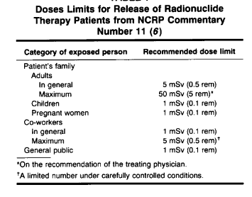

**Figure1: international Release criteria**

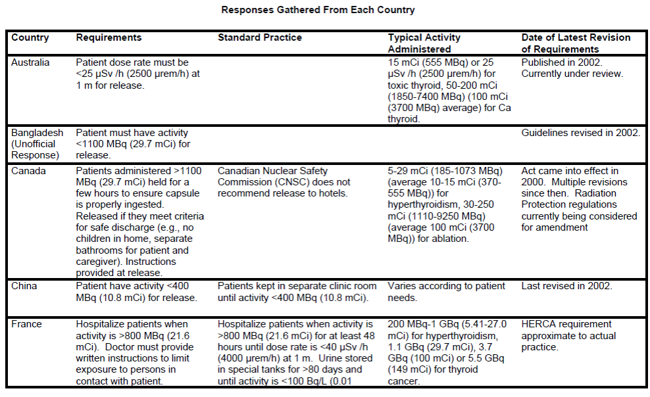

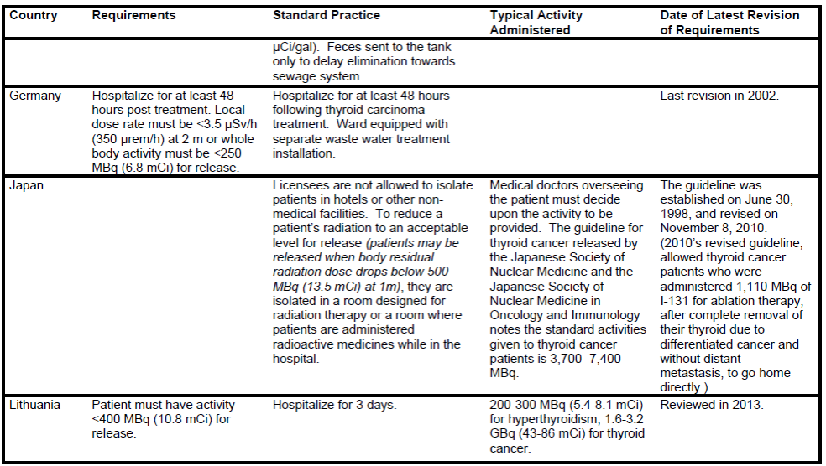

**Record Keeping Of Iodine Treated Patients**

AEMCK has developed a computer modal for release criteria of iodine treated patient, this modal knows about 1000 of patients based on their individual condition. As no two patients anywhere in world are alike, they must administered with same dose but due to change in physical, biological, mental, economical condition their release criteria from isolation are different. In such condition the prediction of individual release is immensely complicatd. But we are developing AI modal that can help streamline this process by taking information from number of sources. And with help of these data the AI helping the doctors/physicist to learn from patient with similar condition and make highly informed decision about their release.

These recordkeeping requirements may also be used to verify that licensees have proper procedures in place for assessing potential third-party exposure associated with and arising from exposure to patients administered radioactive material.

To minimize exposure to radiation to others from the source inside your body, you should do the following for ______ days.

* + Stay at a distance of _____ feet from _____________________.
  + Maintain separate sleeping arrangements.
  + Minimize time with children and pregnant women.
  + Do not hold or cuddle children.
  + Avoid public transportation.
  + Maintain a prudent distance from others for at least the first 2 days,
  + - Sleep alone in a room for at least the first night, Do not travel by airplane or mass
  + transportation for at least the first day,
  + - Do not travel on a prolonged automobile trip with others for at least the first 2 days,
  + - Have sole use of a bathroom for at least the first 2 days,
  + - Drink plenty of fluids for at least the first 2 days.

